EXP NO: 9

Design input forms that validate data (e.g., email, phone number) and display error messages using HTML/CSS, JavaScript (with Validator.js)

To create a simple form that accepts an email and phone number from the user, and validates the inputs using JavaScript and the Validator.js library, displaying error messages for incorrect inputs and a success message for valid inputs

This was built using HTML to structure the form elements , CSS for styling the form layout , JavaScript to add validation logic and Validator.js which is a JavaScript library used to validate user input formats

Step 1: HTML Form Setup

<!DOCTYPE html>
<html lang="en">
<head>
<meta charset="UTF-8">
<meta name="viewport" content="width=device-width, initial-scale=1.0">
<title>Form Validation</title>
<link rel="stylesheet" href="style.css">
</head>
<body>
<div class="container">
<form id="myForm">
<label for="email">Email:</label>
<input type="email" id="email" name="email" required>
<span id="emailError" class="error"></span>

<label for="phone">Phone Number:</label>
<input type="text" id="phone" name="phone" required>
<span id="phoneError" class="error"></span>

<button type="submit">Submit</button>
</form>
</div>
<script
src="https://cdnjs.cloudflare.com/ajax/libs/validator/13.6.0/validator.min.js"></script>
<script src="script.js"></script>
</body>
</html>

- Created a form with two fields: Email and Phone Number.
- Each field has a <label>, an <input> element, and a <span> tag for error display.
- A Submit button is added to trigger validation.

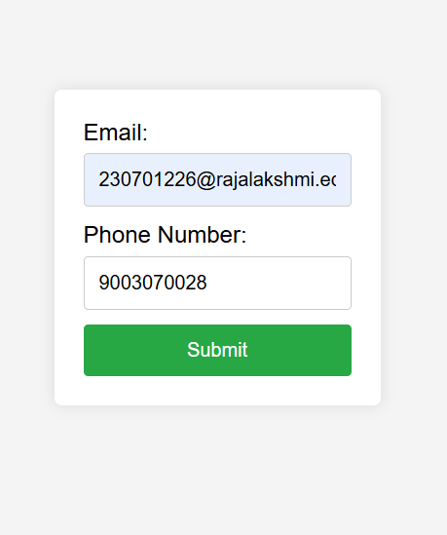

Step 2: CSS Styling

body {
font-family: Arial, sans-serif;
background-color: #f4f4f4;
display: flex;
justify-content: center;
align-items: center;
height: 100vh;
margin: 0;
}
.container {
background-color: white;
padding: 20px;
border-radius: 5px;
box-shadow: 0 0 10px rgba(0, 0, 0, 0.1);
}

form {
display: flex;
flex-direction: column;
}
label {
margin-bottom: 5px;
}

input {
margin-bottom: 10px;
padding: 10px;
border: 1px solid #ccc;
border-radius: 3px;
}

button {
padding: 10px;
background-color: #28a745;
color: white;
border: none;
border-radius: 3px;
cursor: pointer;
}
button:hover {
background-color: #218838;
}
.error {
color: red;
font-size: 0.875em;
}

Used flex display to center the form on the screen.
- Designed a clean and minimal interface using:
- Shadows for the card container
- Rounded borders for inputs
- Green color for the submit button
- Error messages are shown in red using the .error class.

Step 3: JavaScript + Validator.js for Validation

document.getElementById('myForm').addEventListener('submit', function (e) {
e.preventDefault();

let email = document.getElementById('email').value;
let phone = document.getElementById('phone').value;
let emailError = document.getElementById('emailError');
let phoneError = document.getElementById('phoneError');

emailError.textContent = '';

phoneError.textContent = '';

if (!validator.isEmail(email)) {
emailError.textContent = 'Please enter a valid email address.';
}

if (!validator.isMobilePhone(phone, 'any')) {
phoneError.textContent = 'Please enter a valid phone number.';
}

if (validator.isEmail(email) && validator.isMobilePhone(phone, 'any')) {
console.log('Email:', email);
console.log('Phone:', phone);
}
});

On form submission, we:
  - Prevent default submission
  - Grab values from input fields
  - Use validator.isEmail() to check if the email is in correct format
  - Use validator.isMobilePhone() to validate the phone number
  - Show respective error messages if validation fails
  - If both validations pass, show a popup message using alert() that says:
“Form submitted successfully!”

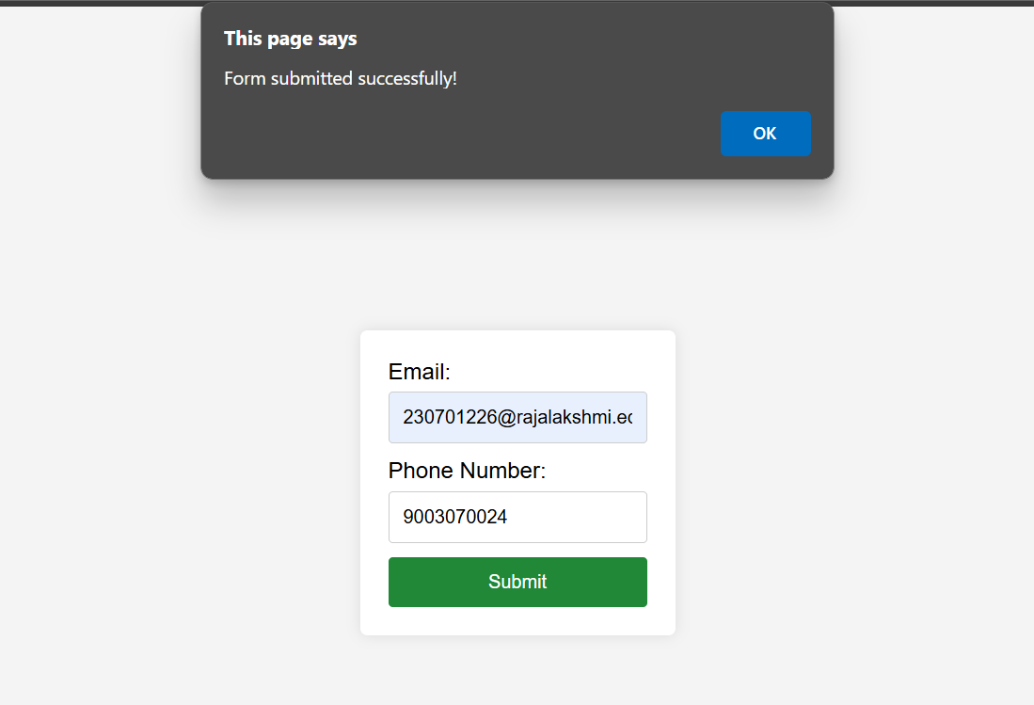
The form validation project successfully validates email and phone number inputs using HTML, CSS, and JavaScript with Validator.js. It displays real-time error messages for invalid inputs and confirms successful submission with a pop-up alert. This enhances user experience by ensuring correct data entry before processing.

